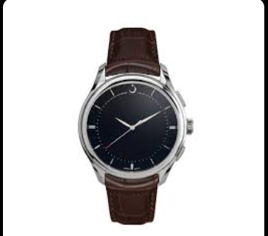

**Product Name:**

Fossil Men’s Quartz Brown Leather Strap Black Dial Watch (Model: BQ2802)

**Description:**

A sophisticated timepiece featuring a **brown leather strap** and a **black dial**, designed for both casual and formal wear. The watch combines elegance with functionality, making it a great choice for everyday use.

**Specifications:**

* **Strap Material:** Genuine brown leather
* **Dial Color:** Black
* **Case Size:** 50mm
* **Movement:** Quartz
* **Water Resistance:** Standard resistance for daily wear
* **Additional Features:** Minimalistic design with three hands (hour, minute, second)

**Price:**

24,500